**PTMD (Police Training Management Department) Interview Templates  
  
----------------------------------------  
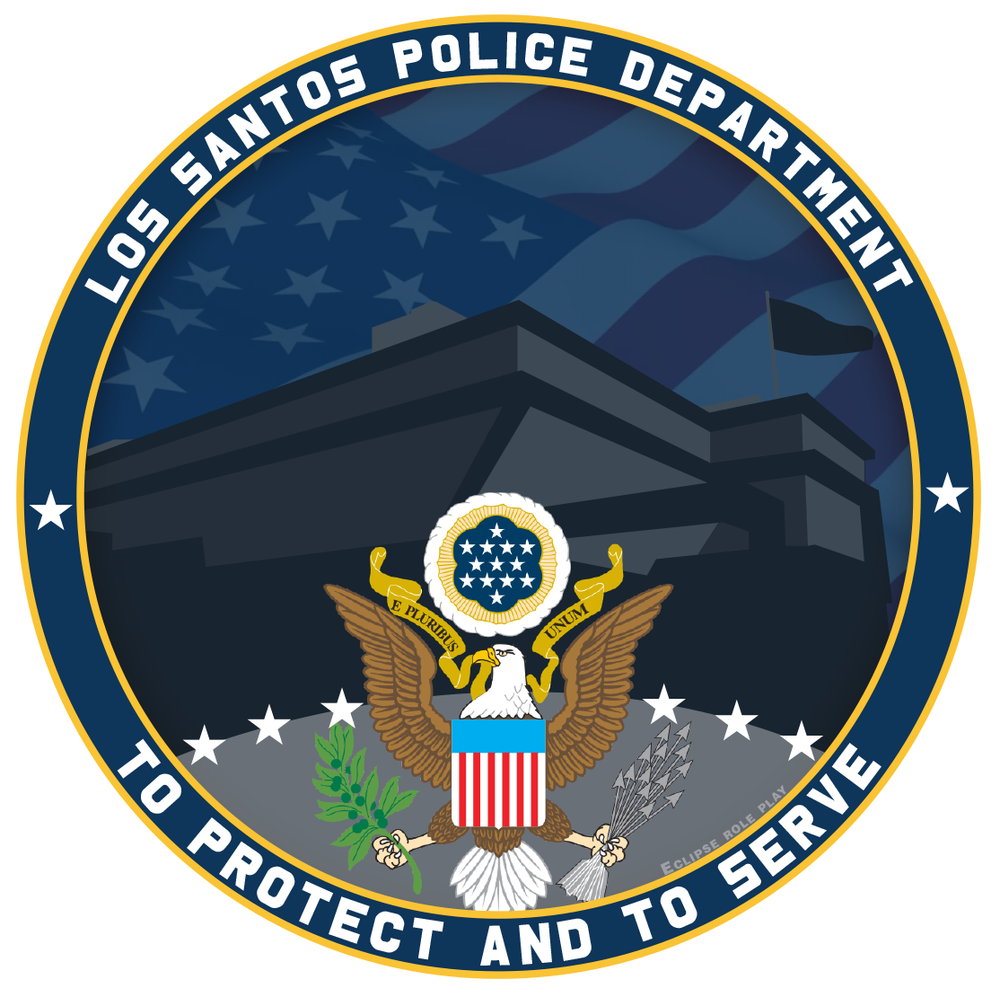**

**Congratulations, You have been Accepted for an Interview.**

**Come to the Project X Discord LSPD channel and join Waiting (under the LAW Section) for an Interview and wait for a management member to contact you.**

**Do not message any management member to hurry up the interview process as this may result in your application being delayed or declined.**

**Please complete your interview by 7 days. Otherwise, your application will be declined.**

**----------------------------------------  
**

## **Congratulations, You have PASSED your interview.You are now officially a part of LAW Enforcement !**

**----------------------------------------**

**----------------------------------------**

**  
Your application has been Denied.**

**Unfortunately, You have Failed your interview.  
Feel free to re-apply in 7 days. If you apply before this date your application will be DENIED and the timer reset.  
Messaging any Management member on attempting to appeal the outcome of your application may result in you being blacklisted, making it harder for you to join the police in the future.  
----------------------------------------**

**Your application has been Denied + blacklisted**

**(Type Reason)**

**Feel free to submit an unblacklist appeal form in the future**

**Messaging any Management member on attempting to appeal the outcome of your application may result in you being blacklisted, making it harder for you to join the police in the future.**

**----------------------------------------  
  
Your application has been placed on hold.  
(Reason)**

**Do not message any PTMD Management member to hurry up the application process as this may result in your application being delayed or declined.**



**Your application has been Denied.**

**(Applications are currently Closed)**

**Feel free to re-apply once applications are Re-opened.**

**Messaging any Management Member in attempting to appeal the outcome of your application may result in you being blacklisted, making it harder for you to join the police in the future.**

**  
Your application has been Denied.**

**(Lack Of Effort)  
  
Feel free to re-apply in 7 days. If you apply before this date your application will be DENIED and the timer reset.  
Messaging any Management member on attempting to appeal the outcome of your application may result in you being blacklisted, making it harder for you to join the police in the future.  
  
  
  
  
  
  
  
**

**Your application has been Denied & Blacklisted**

**(Blacklisted for copying application from another Applicant)**

**Feel free to apply for unblacklisting.**

**Messaging any Management member on attempting to appeal the outcome of your application may result in you being blacklisted, making it harder for you to join the police in the future.**

**  
Your application has been Denied.**

**(You’re Blacklisted from PD)  
  
Feel free to re-apply in 7 days. If you apply before this date your application will be DENIED and the timer reset.  
Messaging any Management member on attempting to appeal the outcome of your application may result in you being blacklisted, making it harder for you to join the police in the future.**